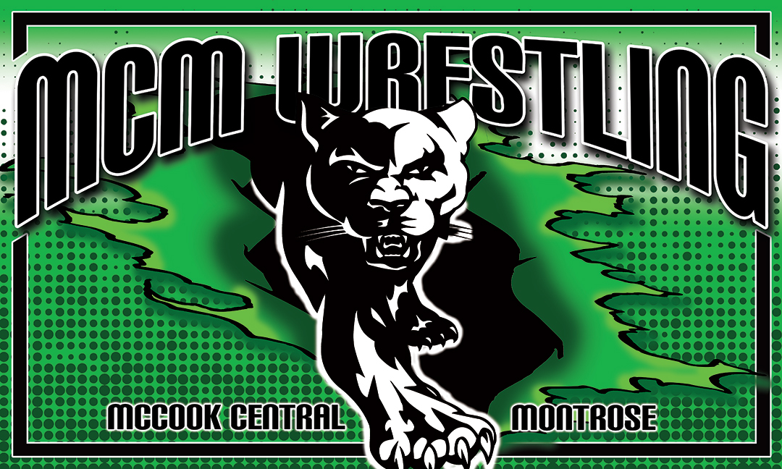

MCM
Youth Wrestling Tournament
Friday, February 1, 2019
Start time: 6:00 PM
Check in: 4:30-5:30PM

McCook Central School Auditorium Salem, SD
We have a new Commons Area and we will be using both Gyms

Round Robin 3 - 1.5-minute periods, choice for each wrestler in 2nd and 3rd periods.

MATSIDE COACHING IS WITH A BAND. COACHES BANDS COST $5.
YOU MUST HAVE A BAND TO BE MATSIDE

Age Groups are by the age you are the day of the tournament.

6 & under, 7&8, 9&10 (4 or 5 man brackets and be in the big Gym)

11&12 will be in the Secondary Gym (6 man round robin brackets where possible)

Girls Brackets by grade K-2nd, 3rd-5th and 6th-8th. Weights will be matched as close as possible.

Must Pre-Register by 1/29/19 6:00 PM
Limit to the First 300 signed up.

Pre-Register: https://docs.google.com/forms/d/e/1FAIpQLSfhsUhsbY3GTYpZpSezXiODDz2wJVCtmcRR0Elah7nmqENN4Q/viewform?usp=sf_link

Entry Fee: $10.00 Per Wrestler (Pay entry fee when you check in, the day of the tourney)

Admission:
$5.00 Adults
$3.00 Students (1-12)

Trophies for 1st and medals for 2nd - 4th places

Concessions will be sold. No Coolers Please
NOT RESPONSIBLE FOR ACCIDENTS

For more information you can contact Casey Remmers
caseyremmers17@gmail.com
421-8095

